HW2 Classifications for diabetes ( 100 pts)

The diabetes_prediction_dataset.csv file contains medical and demographic data of patients along with their diabetes status, whether positive or negative.
It consists of various features such as age, gender, body mass index (BMI), hypertension, heart disease, smoking history, HbA1c level, and blood glucose level. The Dataset can be utilized to construct machine learning models that can predict the likelihood of diabetes in patients based on their medical history and demographic details.

Step 1: Load Data ( 5 pts)
Get Dataset:
https://www.kaggle.com/datasets/iammustafatz/diabetes-prediction-dataset?select=diabetes_prediction_dataset.csv
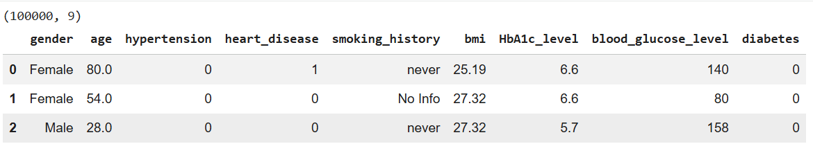
Notes: Diabetes is the target variable being predicted, with values of 1 indicating the presence of diabetes
Step 2: Basic Data Analysis ( 10 pts)
- Show basic Info
- Show number rows and columns
- Show column names
- Show data types
- Show missing data (hint: use df.isnull().sum()
- Show descriptive statistics of age and bmi (Use .describe() )
- Show mean, std, min, max of age and bmi (Use min, max, std, mean function)

Step 3: Data Visualization: show following chart ( 20 pts)
- Create Pie chart for Smoke History
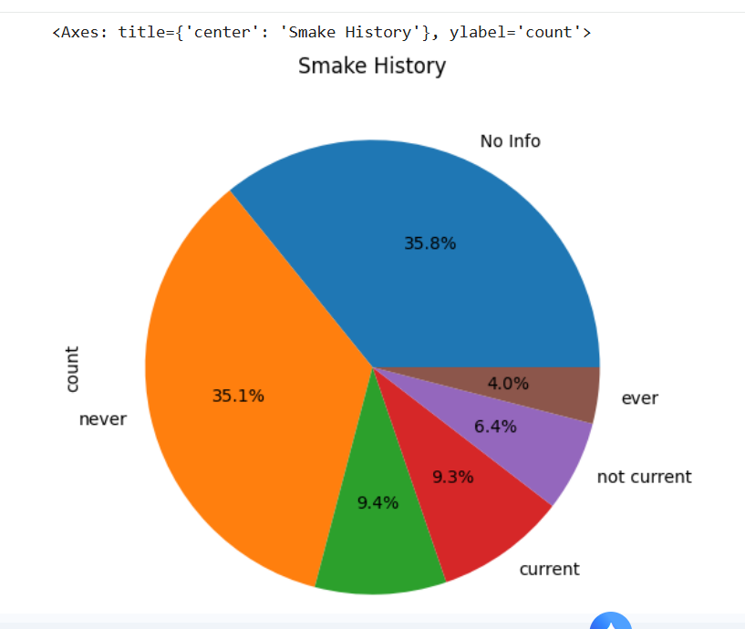

- Bar chart for Smoke History
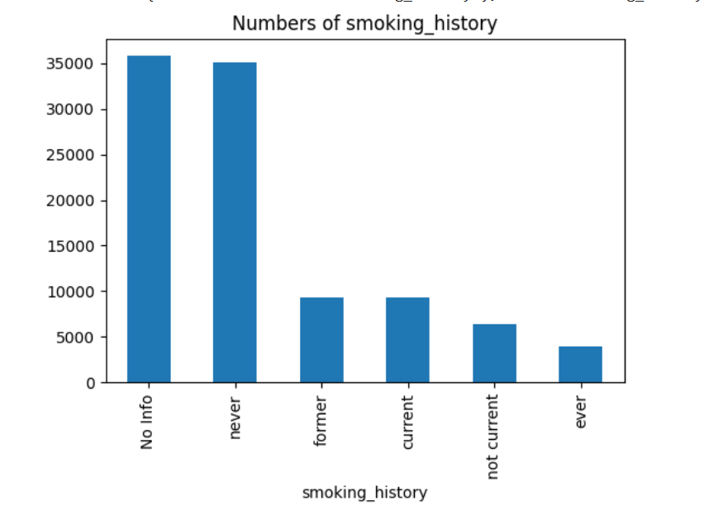

- Histogram chart (Show all bmi)
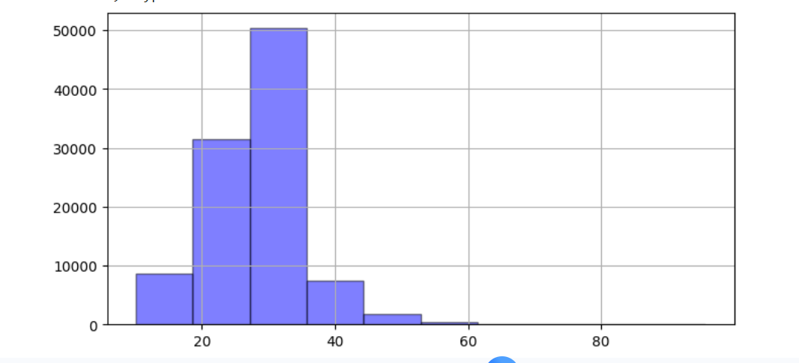

- Histogram chart for Smoke History (Show bmi <50 )

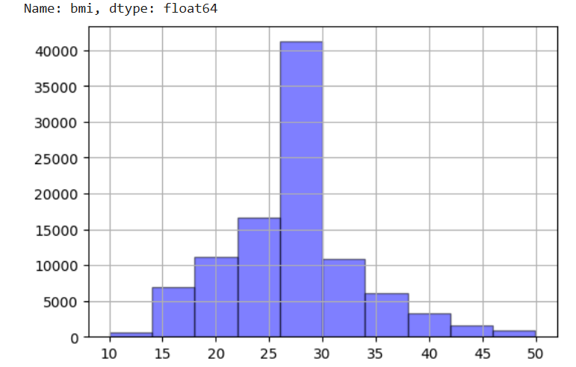

- Charts by your choice
( Suggestion: charts show the correlation of age, bmi to diabetes
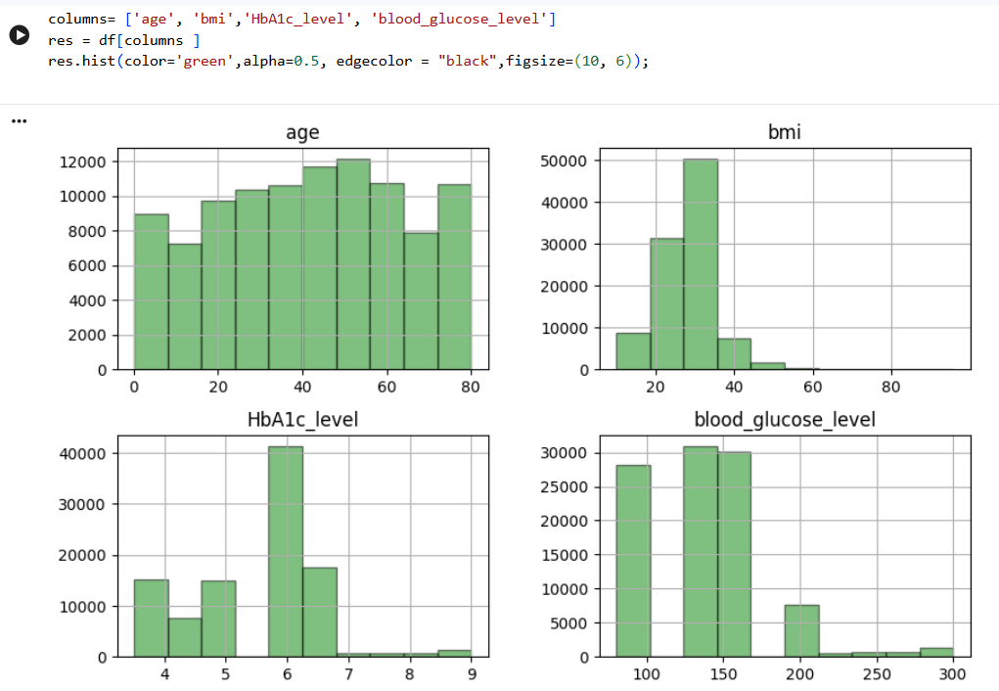
- Target Data
- 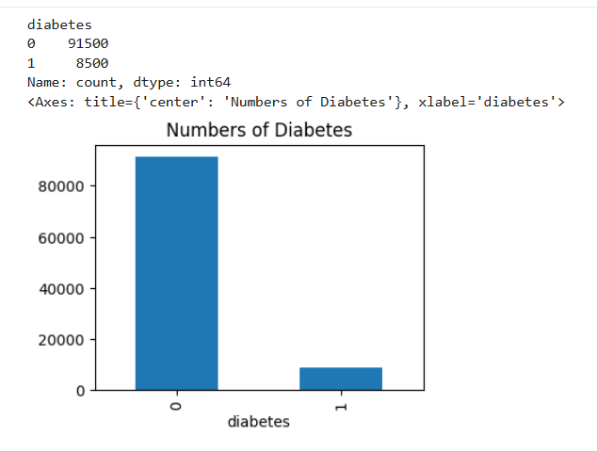

Step 4: Data Processing (20 pts)
Convert categorical features to numerical feature
Method 1 : Using LabelEncoder for gender
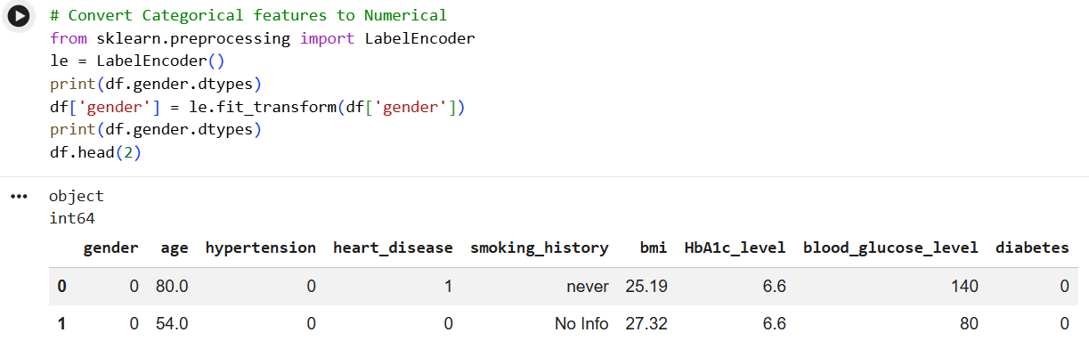
Method 2: Using mapping for Smokeing_history
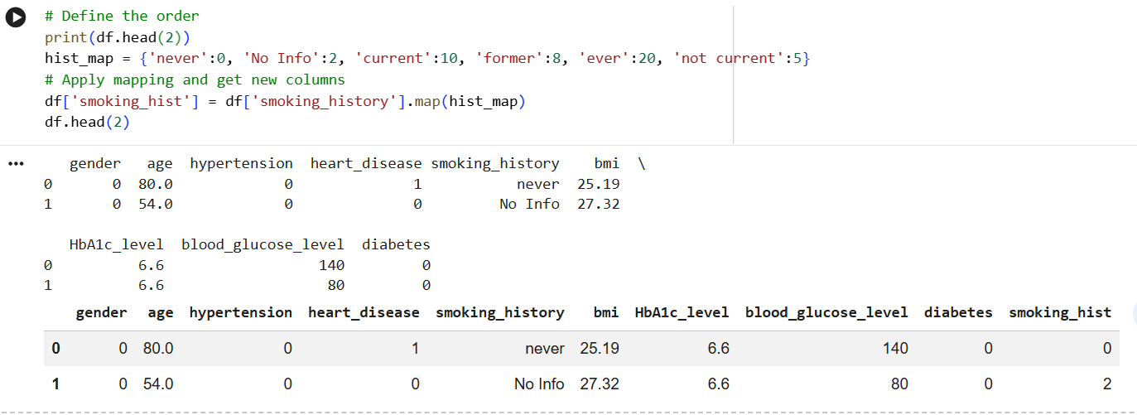

Method 3: Using dummies
Df_us_dummies
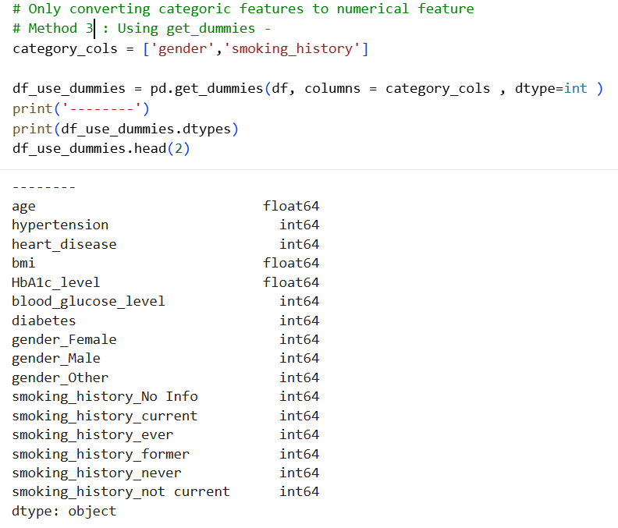
Method 4: One-hot Encoder (Bonus 5 pts)
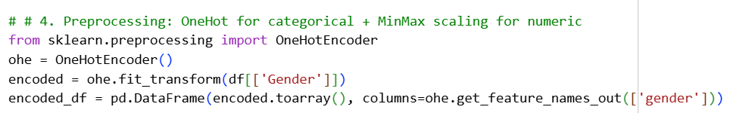

Step 5: Separate Data feature and target ( 5 pts)
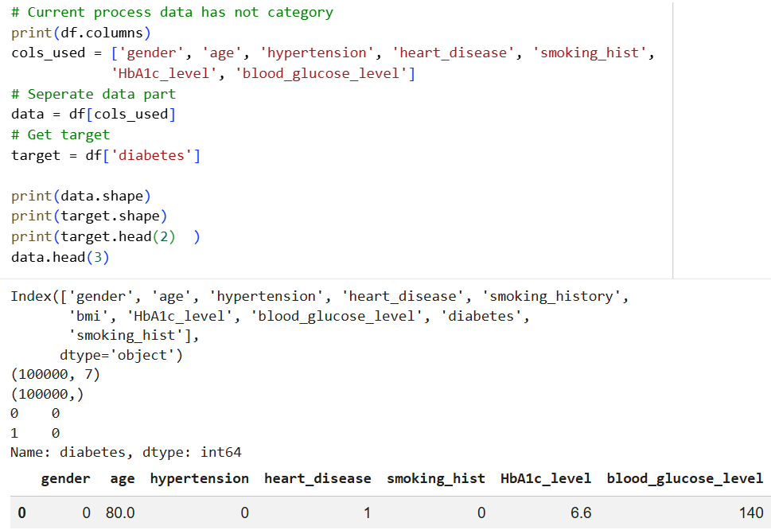

Step 6: Training three classifiers (40)
- Separate training and testing dataset
- Create three classifiers
- Apply testing data
- Evaluation Report
- Confusion Matrix

- Using KNN Classifier: (Try at least three k numbers, hit, use loop)

- Using Decision Tree

- Third Classifier: Your Choice (I Use SVM here)
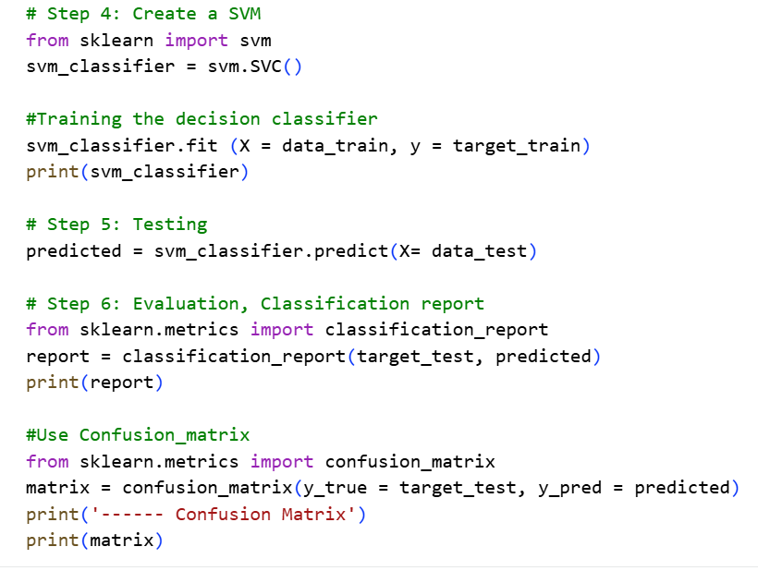
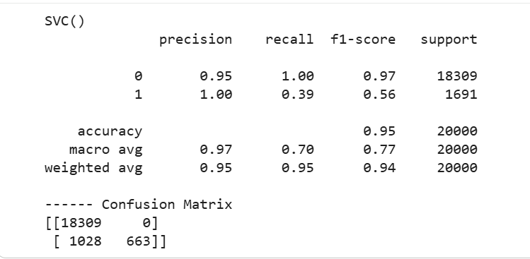

Step 7: Finishing following table: (20 pts)
(Using confusion matrix)
Diabetes is the target variable being predicted, with values of 1 indicating the presence of diabetes
Classifier | TP | FP | TN | FN | Precision | Recall | Accuracy
KNN(K=3) | 650 | 0 | 18292 | 1058 | 1.00 | 0.38 | 0.95
KNN(K=4) | 1263 | 478 | 17814 | 445 | 0.73 | 0.74 | 0.95
KNN(K=5) | 884 | 213 | 18079 | 824 | 0.81 | 0.52 | 0.95
Decision Tree | 848 | 112 | 18180 | 860 | 0.88 | 0.50 | 0.95
SVM | 803 | 88 | 18204 | 905 | 0.90 | 0.47 | 0.95

